10/11/2024
Name of Child: | Pharichat Yoddoysang
Sex: | F
Date of Birth: | 18 Feb 2004
Name of the village: | Bandoykew Maehongson
Religion: | Christian
Name of School or College: | Hongson seksa
Grade or years: | 12
Favorite Subject: | Math and physical
Hobby: | Play sport
Sibling: | One younger brother
Ambition: | Business
Family Background: | she comes from poor family, they have no income, but she want to study high for support her family after get a job.pb
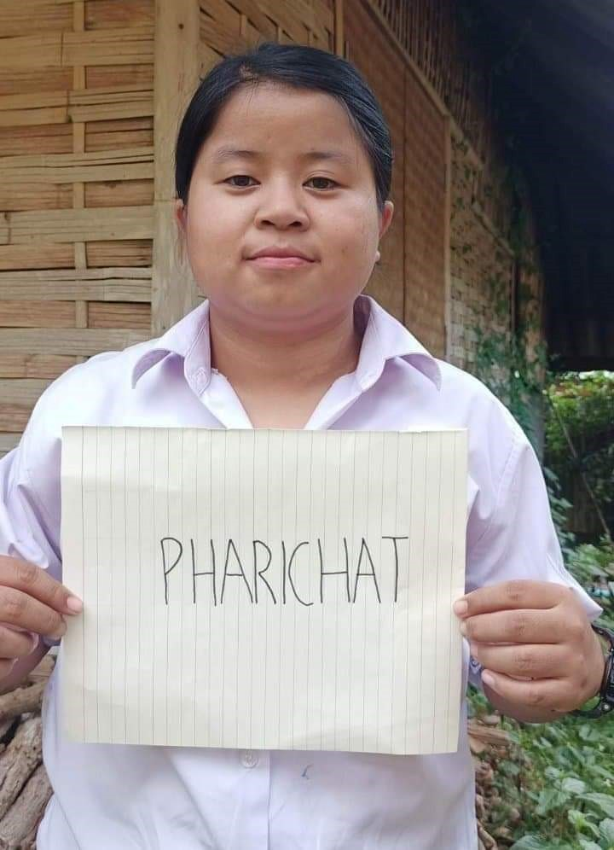

Sponsored by:,

